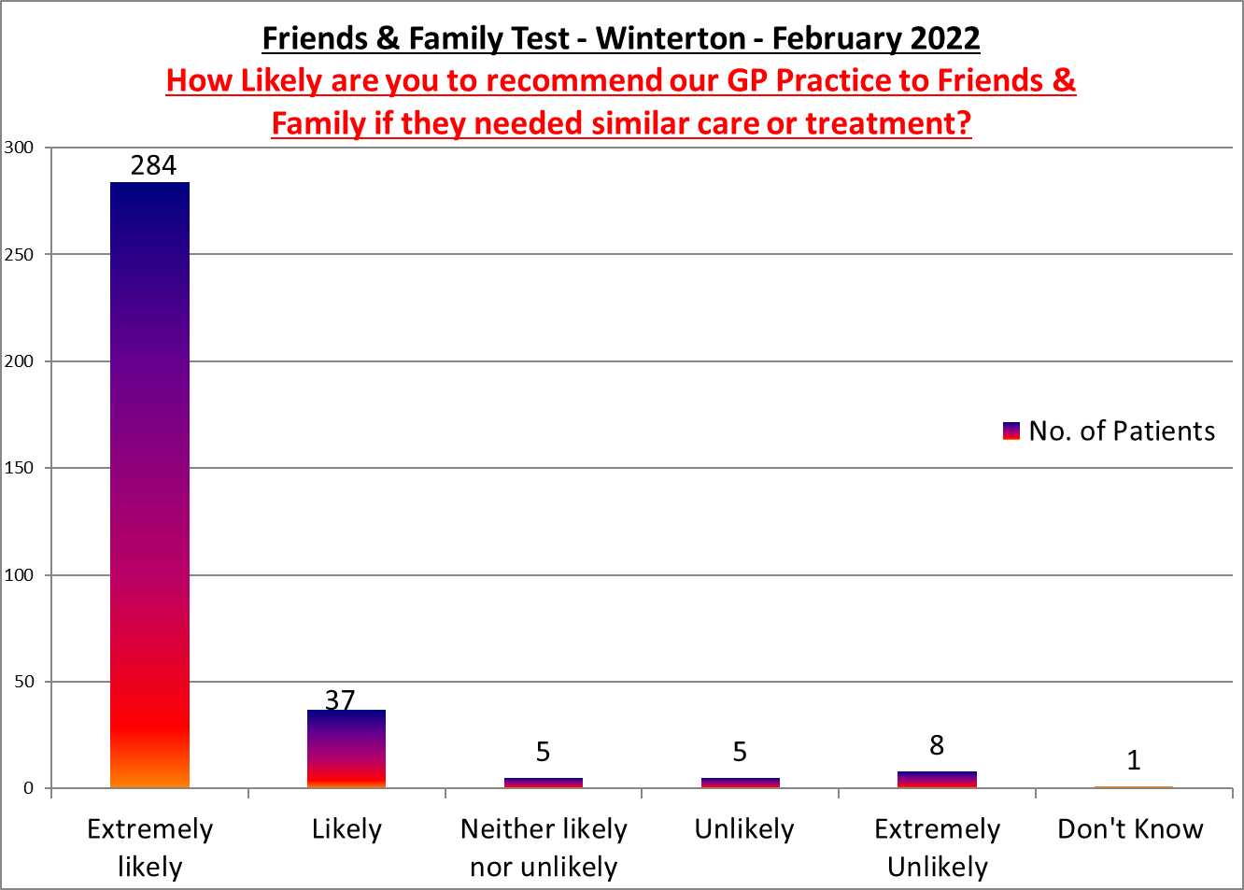

Winterton Surgery

**Positive Comments**

Dr Aung had 2 students with him, they were both thorough and Dr Aung was brilliant helping when needed

On time and the nurse was very professional and friendly

Staff very pleasant and put me at ease

The nurse who as treated me as been incredible. She is so supportive and l feel well cared for. She is a an asset to the surgery

It was wonderful in these troubled times to have someone to create a peaceful and positive climate to listen and suggest strategies.

Excellent care provided by Dr Aung

The staff were kind and helpful.

Unacceptable waiting time which was over an hour.

I was seen early and received a very professional service from Nurse Practitioner Charlie

My visit was excellent. I was called in straight away, listened to, given time to explain everything and was examined without feeling hurried throughout

Thank you everything went well.

Doctor and trainee were very helpful

Excellent home visit by nurse Becky and another nurse trainee

The nursing assistant was very nice, efficient and helpful

Service Brilliant parking rubbish.to many staff cars. many live in village

Very happy with consultation and advice given.

**Negative Comments**

Get better parking and phone system

Dr was late phoning. The line was really crackly and I couldn't hear the dr very well, think he had me on loud speaker.

Excellent service, went for a blood test but asked if my blood pressure could be checked, the nurse did that for me,

We will just say I didn't feel very comfortable and wasn't told before I went in there was a student in there

Terrible doctor hasn't got time to listen cant get you out fast enough

Please allow for all the new houses being built thanks